**Module: SV for Verification**

**Section:** Modules & Classes **Task:** Inheritance

**Task 1**

Inheritance Example

* **Local Keyword Code:**

class parent;

local int x = 10;

endclass

class child extends parent;

int y = 20;

endclass

module tb;

child c;

initial begin

c = new();

$display("Value of x is %d", c.x);

end

endmodule

* + **Findings:**

The local keyword restricts access to the variable x to the class where it is declared. It cannot be accessed by any other class, including derived (child) classes. Attempting to access x from the child class results in a compile-time error.

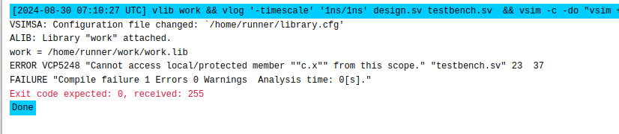

* **Protected Keyword Code:**

class parent;

protected int x = 10;

endclass

class child extends parent;

int y = 20;

endclass

module tb;

child c;

initial begin

c = new();

$display("Value of x is %d", c.x);

end

endmodule

* + **Findings:**

The protected keyword allows access to the member within the class where it is declared and also within any classes that inherit from it. However, it still cannot be accessed from outside these classes (e.g., through an instance in a testbench).

